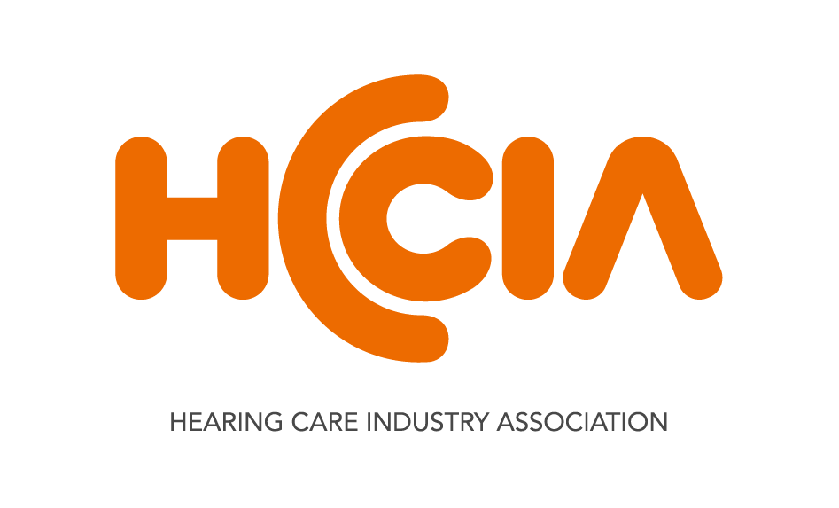

STATEMENT

14 September 2017

HEARING INQUIRY LISTENS – NOW IS THE OPPORTUNITY FOR GOVERNMENT TO ACT

The Hearing Care Industry Association (HCIA) welcomes the Report from the parliamentary Inquiry into the Hearing Health and Wellbeing of Australia. Entitled, “Still waiting to be heard...”, the report was tabled today by the House of Representatives Standing Committee on Health, Aged Care and Sport.
“HCIA has long-championed several recommendations contained in this Report, and we commend the Committee, particularly its Chair, Mr Trent Zimmerman MP and co-Chair, Mr Steve Georganas MP for their excellent work, informed by the economic analysis HCIA commissioned from Deloitte Access Economics,” HCIA CEO Donna Staunton said.
We are particularly pleased about the following recommendations:
#6 The Department of Health…develop and implement an education and awareness raising campaign focused on national hearing health.
#11 The Community Service Obligations program be extended to provide hearing services to hearing impaired Australians aged 26 to 65 years on low incomes or who are unemployed and qualify for lower income support or the Low Income Superannuation Tax Offset; and
#22 Hearing health is made a National Health Priority Area.
“We thank this Committee for listening carefully to the many voices calling for action to support the needs of those with hearing loss in the community. The Committee has reflected beautifully on the recommendations made in a significant 2010 Senate Community Affairs References Committee Report – but now it is the time to get it done.
“We strongly encourage Government to enact these recommendations, given Australia currently has 3.6 million people affected by some form of hearing impairment and, by 2060, it is estimated that this will increase to 7.8 million,” Ms Staunton said.

Ends.

Contact: Donna Staunton, CEO Hearing Care Industry Association 0413 185 724

